Q1.

views.py

from django.shortcuts import render, redirect

from django.http import HttpResponse

from django.template.context_processors import csrf

from django.shortcuts import render, redirect

from urllib.parse import urlencode

def register(request):

if request.method == 'POST':

username = request.POST.get('username')

password = request.POST.get('password')

email = request.POST.get('email')

contact_number = request.POST.get('contact_number')

# Ensure username is provided before redirecting

if username:

# Prepare query parameters

query_params = urlencode({

'username': username,

'email': email,

'contact_number': contact_number,

})

# Redirect to the success page with query parameters

return redirect(f'/success/?{query_params}')

return render(request, 'register/register.html')

def success(request):

# Retrieve the user data from the query parameters

username = request.GET.get('username')

email = request.GET.get('email')

contact_number = request.GET.get('contact_number')

return render(request, 'register/success.html', {

'username': username, 'email': email, 'contact_number': contact_number

})

register.html

<!DOCTYPE html>

<html lang="en">

<head>

<meta charset="UTF-8">

<meta name="viewport" content="width=device-width, initial-scale=1.0">

<title>Register</title>

</head>

<body>

<h1>Register</h1>

<form method="POST">

{% csrf_token %}

<label for="username">Username (required):</label>

<input type="text" name="username" id="username" required><br>

<label for="password">Password:</label>

<input type="password" name="password" id="password"><br>

<label for="email">Email:</label>

<input type="email" name="email" id="email"><br>

<label for="contact_number">Contact Number:</label>

<input type="text" name="contact_number" id="contact_number"><br>

<button type="submit">Submit</button>

</form>

</body>

</html>

success.html

<!DOCTYPE html>

<html lang="en">

<head>

<meta charset="UTF-8">

<meta name="viewport" content="width=device-width, initial-scale=1.0">

<title>Success</title>

</head>

<body>

<h1>Welcome {{ username }}!</h1>

<p>Email: {{ email }}</p>

<p>Contact Number: {{ contact_number }}</p>

</body>

</html>

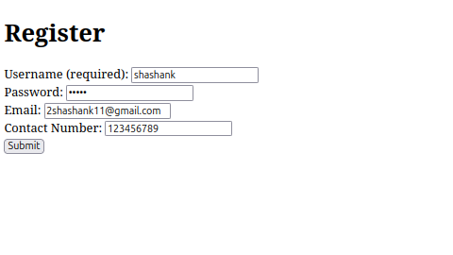

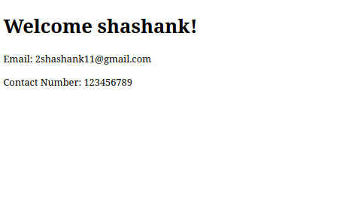

Q2.

models.py

from django.db import models

class Vote(models.Model):

GOOD = 'Good'

SATISFACTORY = 'Satisfactory'

BAD = 'Bad'

VOTE_CHOICES = [

(GOOD, 'Good'),

(SATISFACTORY, 'Satisfactory'),

(BAD, 'Bad')

]

vote_choice = models.CharField(

max_length=20,

choices=VOTE_CHOICES,

default=GOOD

)

def __str__(self):

return self.vote_choice

forms.py

from django import forms

from .models import Vote

class VoteForm(forms.ModelForm):

class Meta:

model = Vote

fields = ['vote_choice']

widgets = {

'vote_choice': forms.RadioSelect

}

views.py

<!DOCTYPE html>

<html lang="en">

<head>

<meta charset="UTF-8">

<meta name="viewport" content="width=device-width, initial-scale=1.0">

<title>Vote Results</title>

</head>

<body>

<h1>Results of the Vote</h1>

<p><strong>Good:</strong> {{ vote_percentages.Good }}%</p>

<p><strong>Satisfactory:</strong> {{ vote_percentages.Satisfactory }}%</p>

<p><strong>Bad:</strong> {{ vote_percentages.Bad }}%</p>

<br><br>

<a href="/">Back to Voting</a>

</body>

</html>

vote.html

<!DOCTYPE html>

<html lang="en">

<head>

<meta charset="UTF-8">

<meta name="viewport" content="width=device-width, initial-scale=1.0">

<title>Vote for the Book</title>

</head>

<body>

<h1>How is the book "ASP.NET with C# by Vipul Prakashan?"</h1>

<form method="POST">

{% csrf_token %}

{{ form.as_p }}

<button type="submit">VOTE</button>

</form>

</body>

</html>

result.html

<!DOCTYPE html>

<html lang="en">

<head>

<meta charset="UTF-8">

<meta name="viewport" content="width=device-width, initial-scale=1.0">

<title>Vote Results</title>

</head>

<body>

<h1>Results of the Vote</h1>

<p><strong>Good:</strong> {{ vote_percentages.Good }}%</p>

<p><strong>Satisfactory:</strong> {{ vote_percentages.Satisfactory }}%</p>

<p><strong>Bad:</strong> {{ vote_percentages.Bad }}%</p>

<br><br>

<a href="/">Back to Voting</a>

</body>

</html>

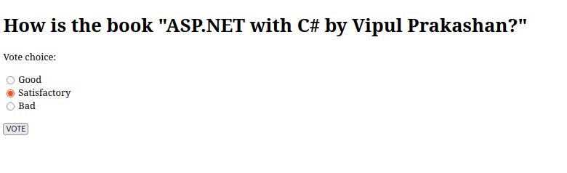

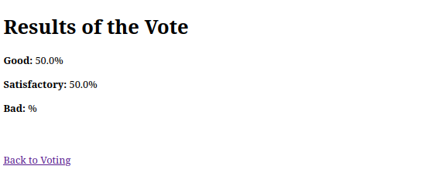

Q3.

views.py

from django.shortcuts import render, redirect

from django.http import HttpResponse

def page1(request):

if request.method == 'POST':

name = request.POST.get('name')

total_marks = float(request.POST.get('total_marks'))

# Store name and marks in session

request.session['name'] = name

request.session['total_marks'] = total_marks

# Redirect to page2 to display the result

return redirect('page2')

return render(request, 'calculator/page1.html')

def page2(request):

# Retrieve the data from session

name = request.session.get('name')

total_marks = request.session.get('total_marks')

if not name or not total_marks:

return HttpResponse("No data found in session", status=400)

# Calculate CGPA

cgpa = total_marks / 50

return render(request, 'calculator/page2.html', {'name': name, 'cgpa': cgpa})

page1.html

<!-- templates/calculator/page1.html -->

<!DOCTYPE html>

<html lang="en">

<head>

<meta charset="UTF-8">

<meta name="viewport" content="width=device-width, initial-scale=1.0">

<title>CGPA Calculator - Page 1</title>

</head>

<body>

<h1>CGPA Calculator</h1>

<form method="POST">

{% csrf_token %}

<label for="name">Name: </label>

<input type="text" id="name" name="name" required><br><br>

<label for="total_marks">Total Marks: </label>

<input type="number" id="total_marks" name="total_marks" required><br><br>

<button type="submit">Calculate</button>

</form>

</body>

</html>

page2.html

<!-- templates/calculator/page2.html -->

<!DOCTYPE html>

<html lang="en">

<head>

<meta charset="UTF-8">

<meta name="viewport" content="width=device-width, initial-scale=1.0">

<title>CGPA Result</title>

</head>

<body>

<h1>CGPA Result</h1>

<p>Name: {{ name }}</p>

<p>CGPA: {{ cgpa }}</p>

</body>

</html>

